Objective and Purpose
This document explains how to transfer stable data from a previous version to a new version of the Data Collection Definition (DCD) for IQECAD. This can save some time, instead of creating a new registration for each patient manually. You will be able to start the new data collection with a list of registrations (from previous data collection) where stable data of patients are already filled out.

Once you have this list do not forget to:
- Delete patients’ registrations not seen during the audit year (left the convention, deceased etc..)
- Add new patients’ registrations seen during the audit year.

Definitions and Abbreviations
Term | Meaning
IQECAD | Initiative for Quality Improvement and Epidemiology in Children and Adolescents with Diabetes
CSV | These files are plain text files which can contain multiple registrations at once and are extracted from your primary system.
DCD | Data Collection Definition, data and terminology model of healthdata.be
HD4DP | Healthdata For Data Provider, data capture solution developed and supported by healthdata.be
Stable Data | Patient data that do not change over time (e.g. birth date, sex etc.)
Upload Center | The CSV file import functionality of HD4DP

Procedure
Transferring stable data from the previous data collection to a new one contains 3 steps in HD4DP:

- Activate participation to the new Data Collection
- Export a CSV file containing the stable data from the previous Data Collection;
- Import the CSV file in the new data collection;
- Update the list: Remove registrations from deceased patients/patients not seen during the audit year. Create registrations for new patients.

- ACTIVATE PARTICIPATION TO THE NEW DATA COLLECTION
You need to confirm the participation to the new DCD before any registrations can be created.

- Log in HD4DP;
- Select IQECAD v5.0 (the new data collection)
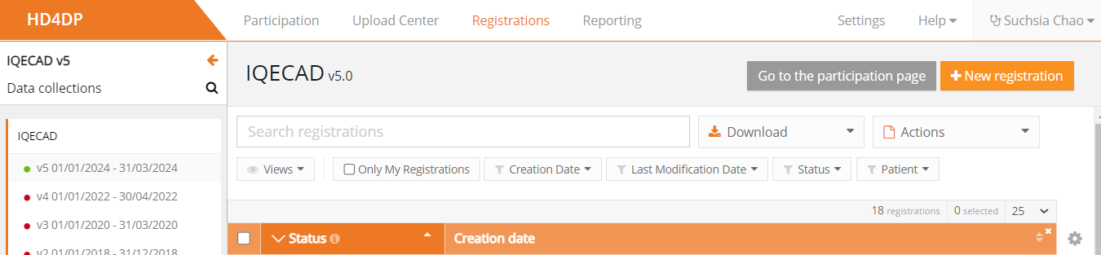

New Data collection (Version 5.0)

- Click on ‘Go to the participation page’
Participation page

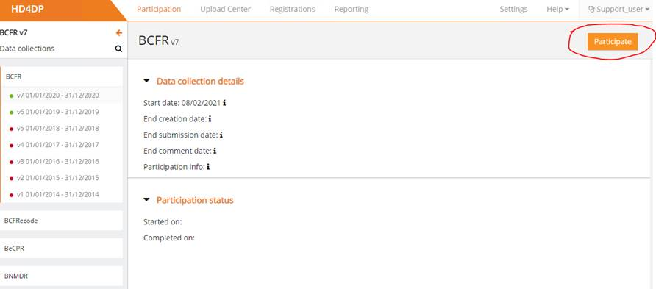
- Click on ‘Participate’

You have activated your participation to the new DCD !

Now let ‘s export a csv file with the stable data (see next step/page)

- Export a CSV file with stable data from the previous data collection
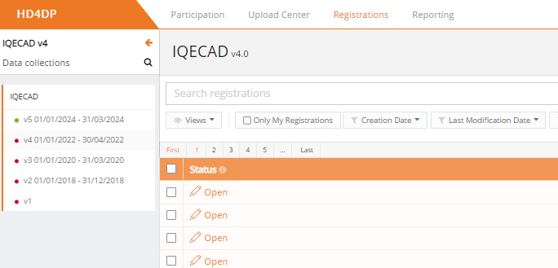
- Select the previous IQECAD Data collection (IQECAD v4)
Click on the previous IQECAD Data collection (v4)

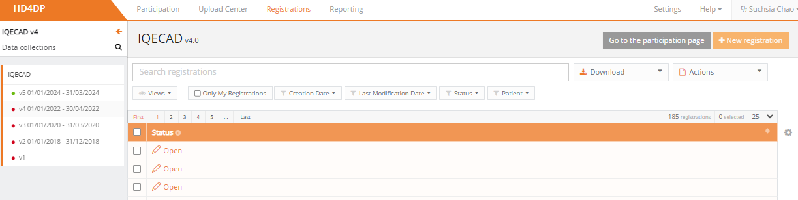
- Go to the panel ‘Registrations’ tab

Registrations tab

- Select only “Approved” registrations from the previous data collection:
- You can sort the list of registrations by clicking on “Status” ( will be in alphabetical order).
Click on “Status” so it is sorted in alphabetical order
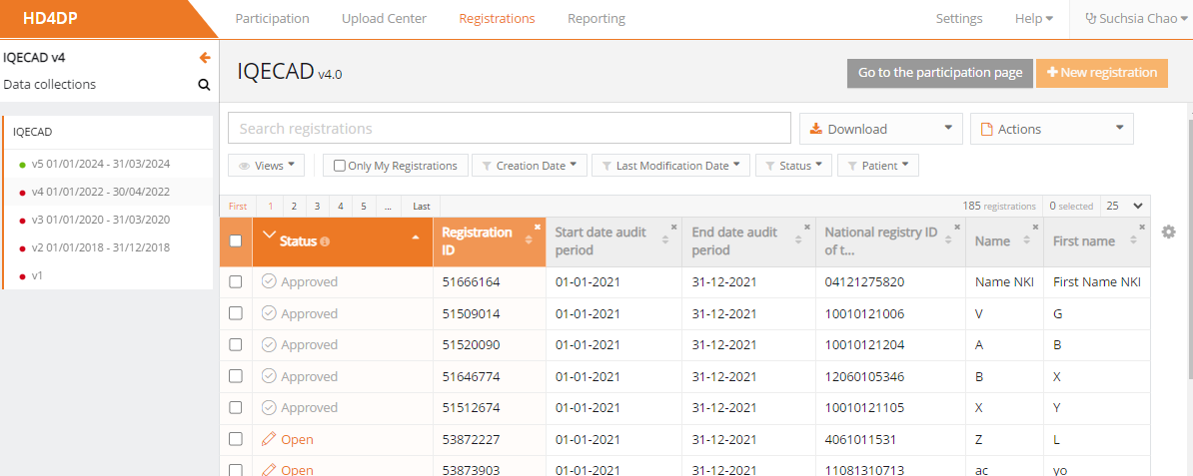
- Now you can see the “Approved” registrations.

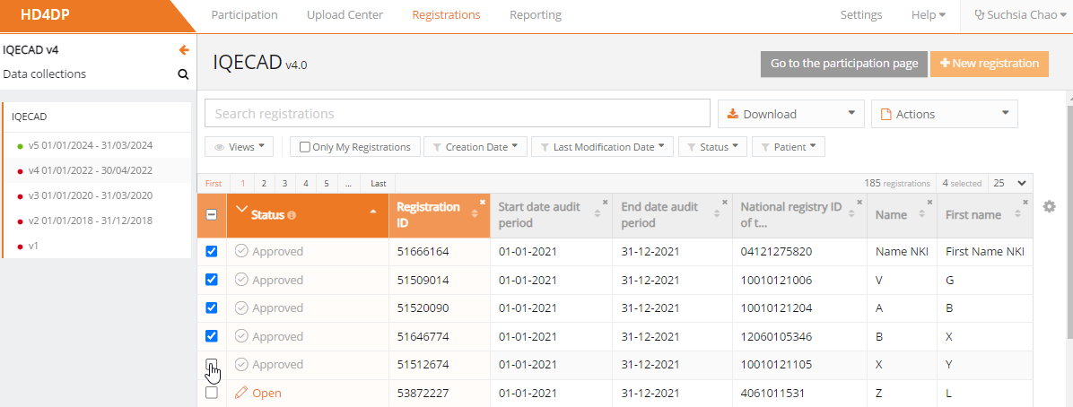
- Select all “Approved” registrations manually one by one or by selecting the whole page.
There may be several pages, so make sure to select all “Approved” registrations.

Click here for selecting all registrations of the page OR…
… Click here for selecting registrations one by one

NB: If you have several pages, select first ‘all’ on the first page, then go to the next page(s) to do the same on each page. At the end, you can manually select the last registrations.

- Once all “Approved” registrations are selected:
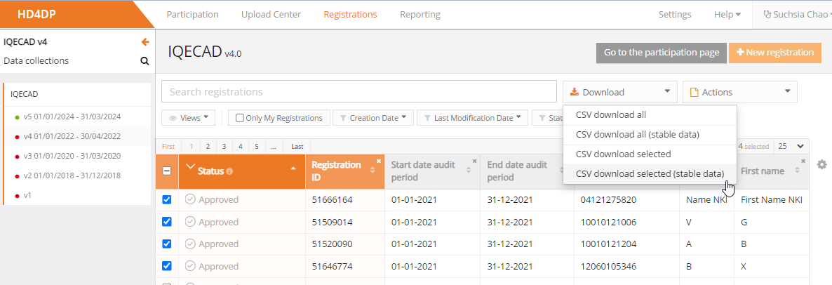
In the right corner, select “Download” menu, select “CSV download selected (stable data)”

- The file “IQECAD.csv” is saved in your download folder.

3. Import the CSV file in the new data collection;

- Select the new data collection IQECAD v5 (Version 5)

New Version (Version 5.0)

- Go to the panel ‘Upload Center’

Go the Panel ‘Upload Center’

- Start a ‘new upload’

- Select ‘Use default configurations’
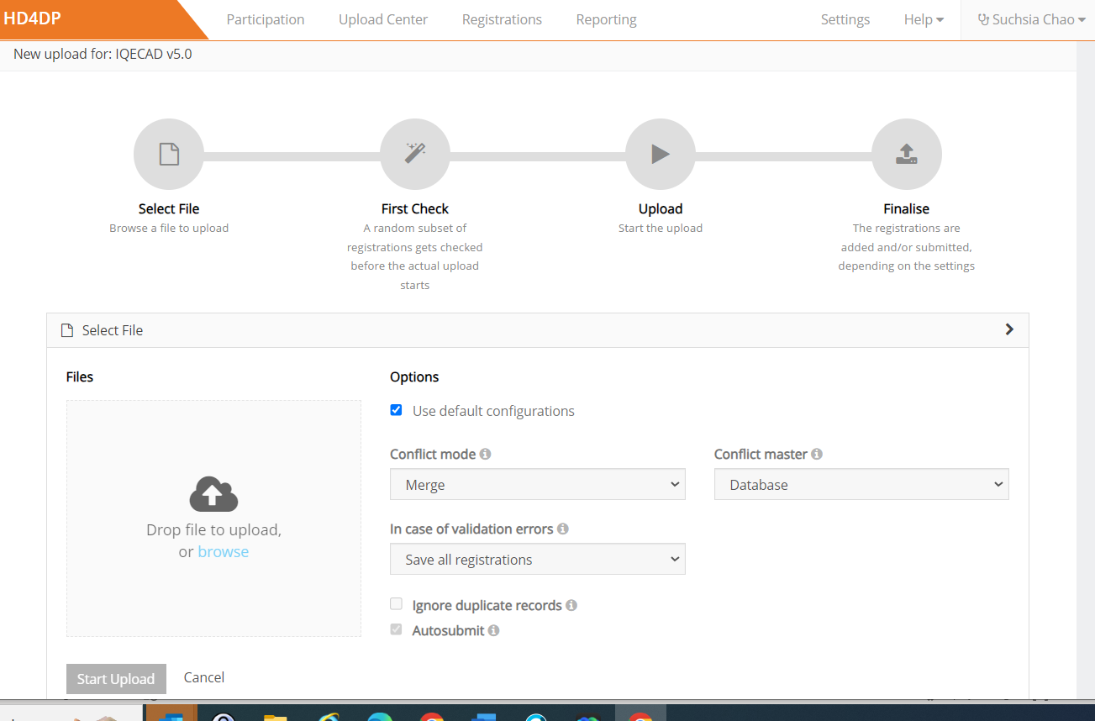

- Use to upload the file ‘IQECAD.csv’ (in the downloads folder).

2. Click on Browse
1. Keep default configuration

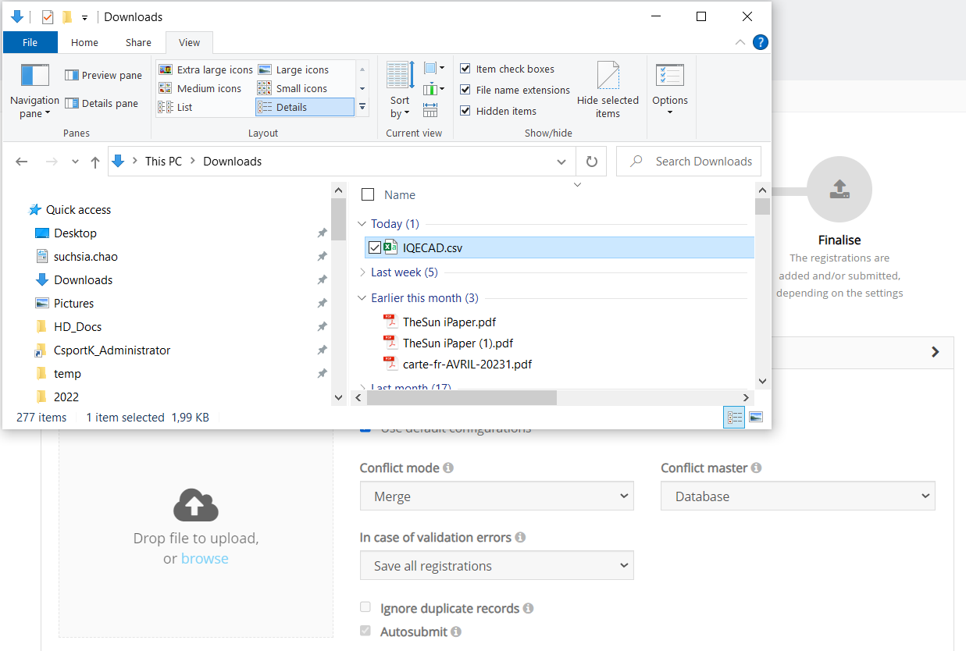
- Select the CSV File to upload: Select the “IQECAD.csv” file, previously downloaded.

Select the file ‘IQECAD.csv’ to upload (‘in your Downloads folder)

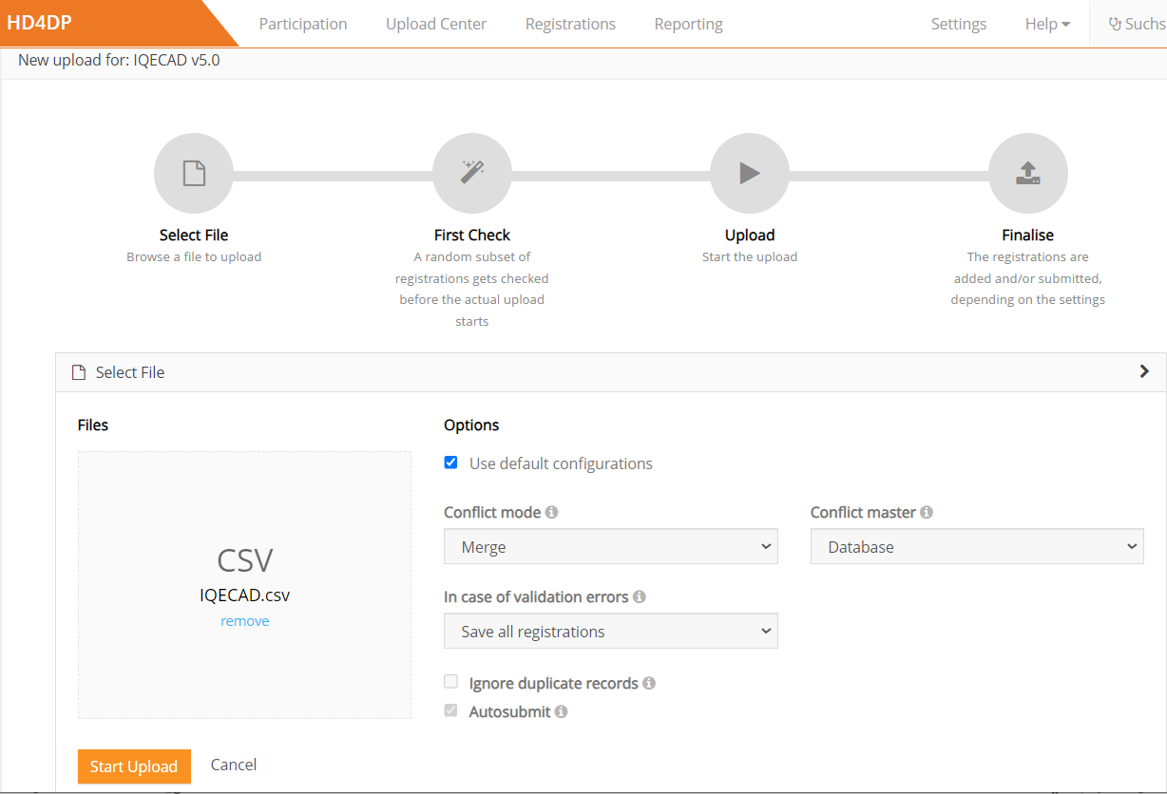
- Untick ‘Autosubmit’ before clicking on ‘Start Upload’

Click on ‘Start Upload’

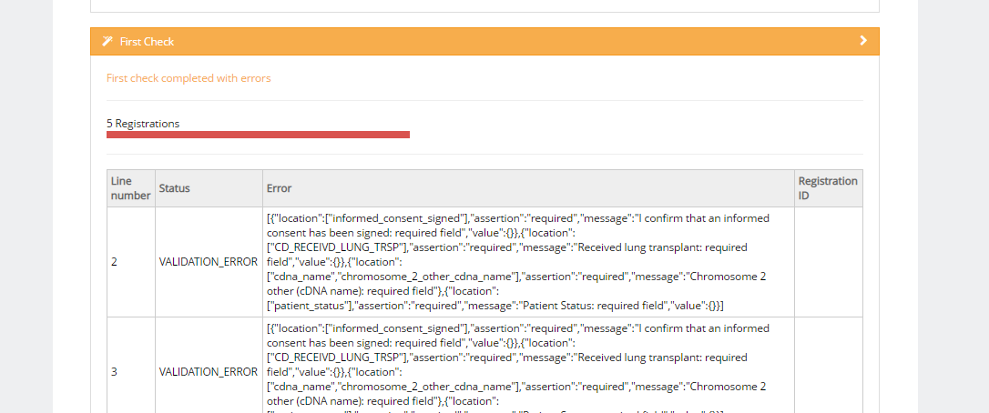
- The application will return the following ‘First check’ screen:
[This is normal that it contains errors]

- You can proceed with the full upload by clicking on the new ‘Start upload’
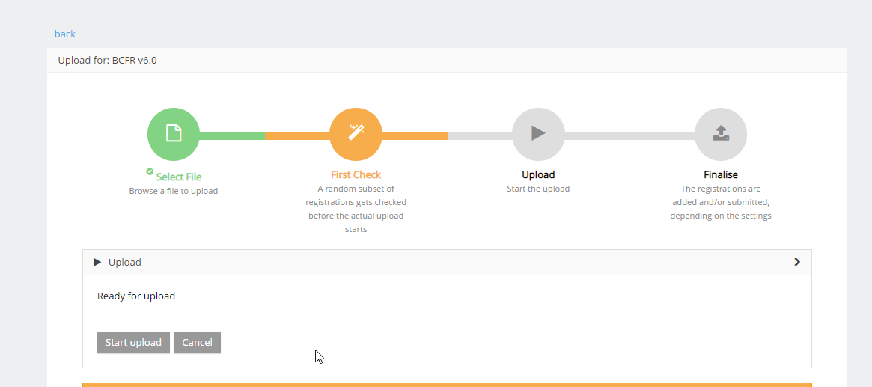

Click on ‘Start Upload’ for starting the Upload

- If you already have uploaded registrations in the past, you will need to select the desired Upload to use (if you do this for the first time, skip this step).
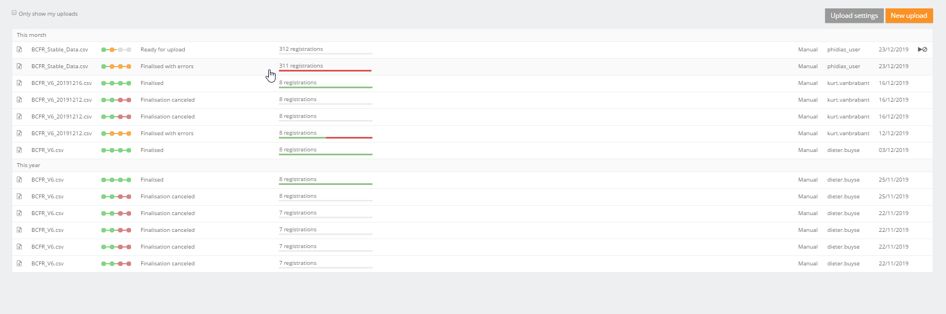
Select on the desired Upload

- Optional:
In the ‘Finalise’ tab: You can click on “Ignored registrations” to see the list of Ignored registrations (not imported in HD4DP). If there is no “Ignored registrations” button, it means that all registrations have been uploaded in the IQECAD Data collection v5.
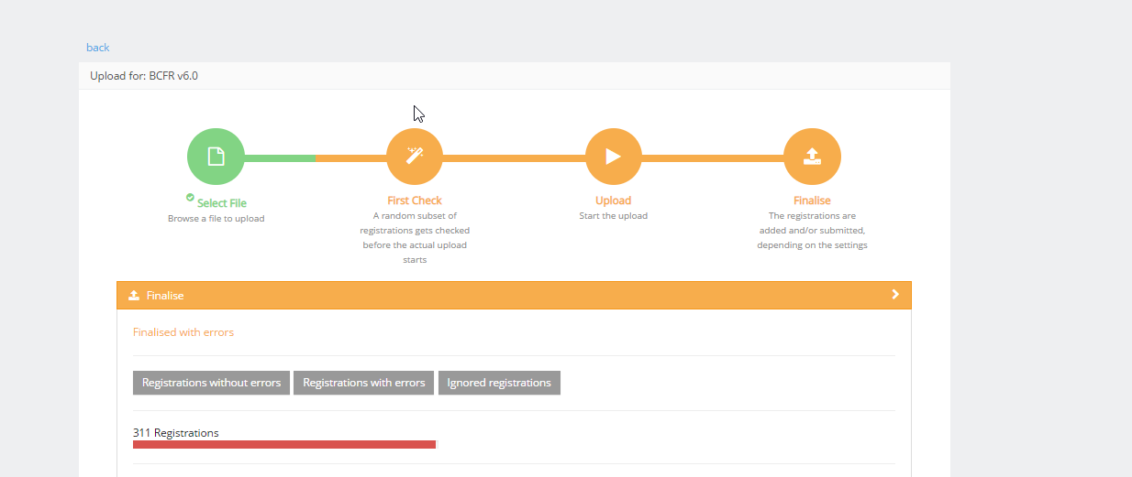

You can click on this button to export a csv file with all the Ignored registrations (not imported in HD4DP).

- Go to the ‘Registrations’ tab.
- Your uploaded registrations have the status ‘Open’: Click on ’Status’ and select ‘Open’
NB: if the new files don’t show up, refresh the page after a few minutes.
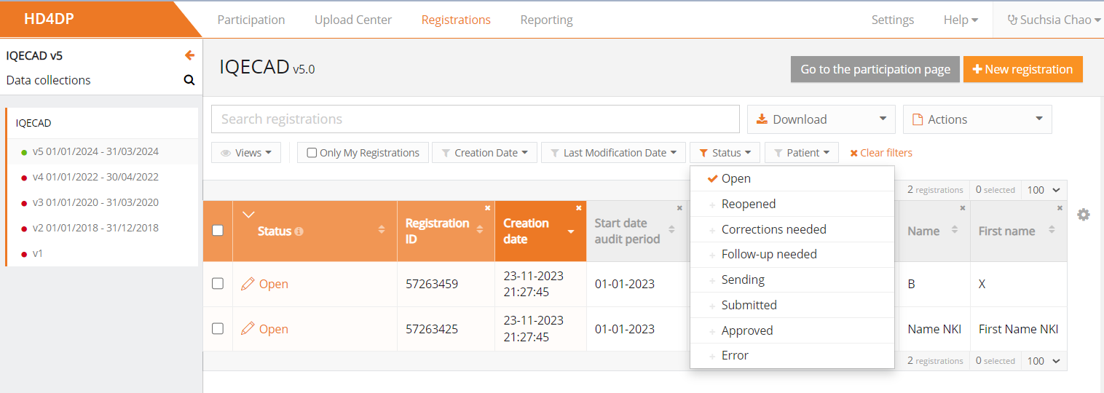

Select Open status to see you uploaded registrations
- Your upload is done ! You have now a list of patient’s registrations (from the previous audit) in which all stable data are already prefilled. Don’t forget to update this list: delete registrations of patient who were not seen during the audit year + create registrations for new patients.
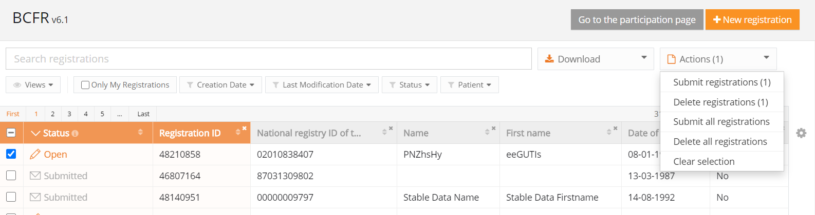

- To delete registrations: Select them, go to Actions, and select Delete registration (n), and confirm the deletion with Yes.

Go to ‘Actions’ then ‘Delete registration (n)’

Create new registrations

Stable data appearing upon NISS input

If you have limited number of patients, you can alternatively create each patient registration individually.
When writing the National registry ID (NISS) in the new registration, it will automatically fill in the stable data (date of birth and gender etc..), if a registration with the same NISS was submitted in a previous data collection.

- Log in HD4DP
- Select the new version of the IQECAD Data Collection (Version 5)
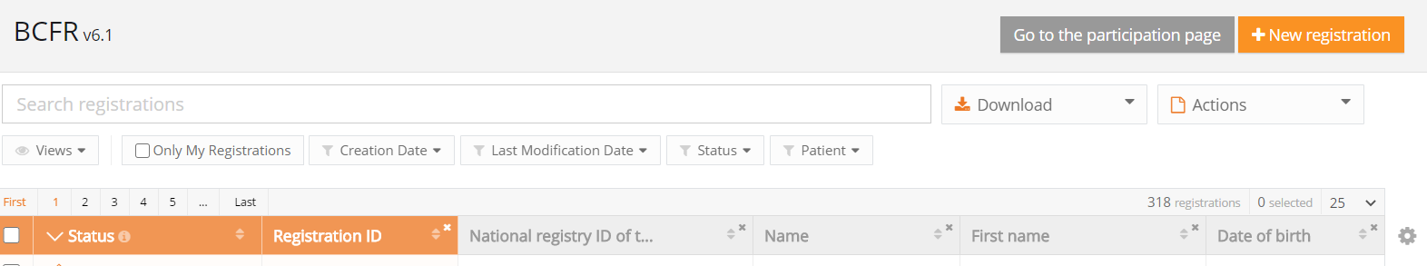
- Click on ‘New registration’ at the top right

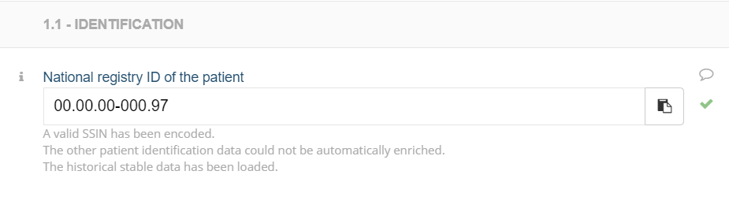
- Write the NISS; after a few seconds, a confirmation message should appear, and stable data appear in the new record

